Einstein Jr. Project
As a part of an attempt to move toward the State’s new Common Core standards, this year’s 6th grade science project will focus on the design process which can spark students’ curiosity about their world, ignite their creativity, and hone their problem-solving skills. The project has a STEM (Science, Technology, Engineering, & Math) focus. Each student has selected a different challenge which showcases engaging, real-life applications of engineering. The challenge sheets are labeled with each step of the design process. The design process offers students a structured way to take an idea from its initial to its “finished product” stage, learning from mistakes along the way. In this packet you will find all of the items needed to complete the Einstein Jr. Project. Students will be instructed in class how to complete each component of the project, BUT will be responsible for completing each part for their chosen challenge at home. For conducting the challenge, it will be each student’s responsibility to obtain the needed materials, have parent supervision, and complete each phase of the project. Please see your teacher if you need any help arranging materials or have any questions.

Due Dates:
- Challenge Selection: __February 27th__
- Parent Permission Slip(10 pts.): __February 28th__
- Design Research(20 pts.): __March 7th_____
- Brainstorm (10 pts.): March 14th_____
- Build Plan(10 pts.) : __March 21st____
- Create Data Table: __March 28th____
- Testing Procedures(10 pts.): ___April 4th______(Data Chart completed while
conducting your tests)
- Redesign/Retest Procedures(10 pts.) : __April 18th______
- Completed Data Table __April 25th_____
- Results: graphs, photos, etc. (10 pts.): ___May 2nd______
- Reflection (10 pts.): ___May 9th______
- Display Boards (100 pts.): ___May 20th_____

*Reminder: Dates may be changed according to the needs of the class. It is the responsibility of the student to record date changes in his/her planner and communicate these changes with his/her parents/guardians. * ALL PARTS LISTED ABOVE WITH AN ASTERISK MUST BE TURNED IN TYPED ON THE ASSIGNED DUE DATE.

We have read the Einstein Jr. Project packet and are aware of the requirements and deadlines.

_____________________________ ______________________________
Student Name Parent Signature
Name ___________________
Design Research

Period _______

*Reminder: You may NOT use Wikipedia

Challenge Name: ________________________________________________________

Web Address or URL: __________________________________________________________________________________________
Website name: _____________________________________________________________________________
Author of website article (if available): __________________________________________________________
Title of website article: ______________________________________________________________________
Date of copyright or last website update: ______________________________________
Date YOU accessed the website: ________________________________________

In the 1st paragraph, summarize what you have read from your research article. You may attach another paper if you wish. Please remember that a summary MUST be in YOUR own words, pulling out the main information from the article. In your 2nd paragraph, you will need to explain how your research will help in planning your design. Each paragraph should have a minimum of five sentences.

Paragraph1:_____________________________________________________________________________________________________________________________________________________________________________________________________________________________________________________________________________________________________________________________________________________________________________________________________________________________________________________________________________________________________________________________________________________________________________________________________________________________________________________________________________________________________________________________________________________________________________________________________________________________________________________________________________________________________________________________________________________________________________________________________________________________________________________________________________________________________________
Paragraph 2: What ideas from your research will you use in your design???
This research has helped me with my design because….____________________________________
________________________________________________________________________________________________________________________________________________________________________________________________________________________________________________________________________________________________________________________________________________________________________
____________________________________________________________________________________________________________________________________________________________________________________
2. Print out a copy of the article and staple it to the back of this page.

3. Use the Cite It Right Resource or the www.knightcite.com website to correctly cite your article using MLA format. Please put the citation on the bottom of your research summary. See example outline below.

4. Turn in a typed, edited, grammatically correct copy to your teacher on the specified due date in MLA format.
Smith 1
Joe Smith

Mrs. Teacher

Science 6

3 March 2014

Design Research: For: Challenge Name

Rockets were created by the ancient Chinese and have been used for centuries. The rocket design consists of a cone and fins that help propel the rocket through the sky. Modern day rockets have been greatly influenced by Newton’s three Laws. When there is an unbalanced force put on a rocket, the rocket undergoes a change or speed in direction. The amount of force produced by the rocket engine will determine the rate at which the rocket will accelerate. The large amount of fuel being burned causes the rocket to push the gas out of the engine as quickly as possible. The reaction of this motion of the rocket is equal to and in the opposite reaction and thrusts the rocket up. The fins and the cone help propel the rocket in a straight direction. A rocket can travel over 40,250 km per hour, this is called the escape velocity.
This research has helped me plan my rocket design. My challenge is to design a rocket that can hit a target and this research has showed me not only how a rocket works, but why it is important to have fin and cone designs that will make my rocket go straight. If my rocket can go straight, then there will be a greater chance that my rocket will hit the target. Also, my research helped me to understand how Newton’s three laws are important to my rocket design in that all objects will stay at rest until another force acts on it. I will have to design a way for my rocket to launch by having a force act on my rocket.

MLA Citation:"NASA Quest ." Rocket Principles. N.p., 2010. Web. 17 Feb. 2013. <quest.nasa.gov/space/rockets/principles/html>.

Example:

CITE IT RIGHT

Citing a print encyclopedia
Format:
Author’s name. “Article title.” (enclosed in double quotation marks) Publication
title. (in italics)Edition (if stated). Year of publication (do not included if stated in edition information). Publication medium.

Example:
Beller, Steven. “Vienna.” The World Book Encyclopedia.2009 ed. Print.

Citing a magazine article
Format:
Author’s name. “Article title.” (enclosed in double quotation marks) Publication
title(in italics) Date of publication: page numbers. Publication medium.

Example:
Jackson, Thomas A. “Power for a space Plane.” Scientific American Aug. 2006: 56-
62. Print.

Citing a newspaper
Format:
Author’s name. “Article title.” (enclosed in double quotation marks) Publication
title(in italics) Date of publication, edition (if given), section letter or number (if applicable): page numbers. Publication medium.

Example:
Wronski, Richard. “Prairie Parkway Project on a Road to Nowhere?” Chicago
Tribune 4 May 2009, sec. 1:6. Print.

Citing a book with one author
Format:
Author’s name.Full book title.(in italics)Edition (if stated). Volume number(s) (if
a multivolume work). City of publication: Publishers name, year of publication. Publication medium.

Example:
Eshleman, Clayton. Grindstone of Rapport: A Clayton Eshleman Reader. Boston:
Black Window Press, 2008. Print.

Citing a book with two or more authors
Format:
Author’s name (last name first), next listed author’s name(s) in normal form. Full
book title. (in italics)Edition (if stated). Volume number(s) (if a multivolume work). City of publication: Publisher’s name, year of publication. Publication medium.

Example:
Gates, Henry L. Jr., and Evelyn B. Higginbotham, eds. African American National
Biography. 8 vols. New York: Oxford University Press, 2008. Print.

Citing a blog
Format:
Author’s name. “Title of individual blog entry.” (enclosed in double quotation
marks) Title of blog. (in italics) Date posted. Publication medium. Date accessed.

Example:
West, Jessamyn. “on the road.” librarian.net. 27 February 2009. Web. 10 March
2009

Citing an ebook
Format:
Author’s name.Full book title.(in italics) Edition (if stated). Volume number(s) (if
a multivolume work). City of publication: Publisher’s name, year of publication. Title of database or Web site.(in italics) Publication medium. Date of access.

Example:
Wharton, Edith. The Age of Innocence.New York: D. Appleton and Company
1920. World Book Advanced. Web. 16 January 2009

Citing a website
Format:
Author’s name.“Article or web page title” (if a part of larger work). (enclosed in
double quotation marks) Web site title. (in italics) Publisher or sponsor of the site, Date of publication Publication medium. Date of access.

Example:
Beasley, Maurine H. “Foosevelt, Eleanor.” World Book Student.World Book, 2009.
Web. 20 Jan. 2009.

Citing a radio or television program
Format:
“Episode or segment title.” (enclosed in double quotation marks) Program title.(in
italics) Name of the network. Call letters, city of local station (if any), Broadcast date. Medium of reception (radio or television).

Example:
“State of Denial.” 60 minutes. CBS. WBBM, Chicago, 1 Oct 2006. Television.

Citing a podcast
Format:
“Description or title of individual podcast.” (enclosed in double quotation marks)
Title of podcast program or series.(in italics) Title of Web Site (if distinct from title of podcast program or series). (in italics) Publisher of podcast, Date of publication. Publication medium. Date of access.

Example
“Iconic Images Emerge from Mideast Summits.” All Things Considered. Natl.
Public Radio, 27 Nov. 2007. Web. 6 Jan. 2009.

Citing a film or video recording
Format
Title of film or video recording. (in italics) Director (if given). Original release date
(if relevant). Distributor, year of release. Publication medium.

Example
America’s Endangered Species: Don’t Say Good-Bye. Dir Robert Kenner. National
Geographic Society, 2008. DVD.

Citing a government publication
Format
Government name. Issuing agency name. Publication title. (in italics) City of
publication: Publisher, year of publication. Publication medium.

Example
United States. Census Bureau. Statistical Abstract of the United States: 2002.
Springfield, VA: National Technical Information Service, 2001. Print

Citing a pamphlet
Format
Author’s name.Pamphlet title. (in italics) City of publication: Publisher’s name,
year of publication. Publication medium.

Example
Modern Language Association.Language Study in the Age of Globalization: The
College-Level Experience. New York: MLA, n.d. Print.

Citing a personal interview
Format
Interviewed person’s name.Kind of interview. Date of interview.

Example
Meyers, Davin. Personal interview. 4 May 2009.

USE THE FOLLOWING ABBREVIATIONS FOR INFORMATION YOU CANNOT SUPPLY.

n.p. No place of publication given.
n.p. No publisher given.
n.d. No date of publication given.
n. pag. No pagination given.

Name ________________________

Period ____

My Problem/Challenge (in the form of a question! Not the title): ____________________________________________________________________________________________________________________________________________________________________________________

My Ideas: List at least 4 ideas you have for your design after your research
1.____________________________________________________________________________________________________________________________________________________________________________________________________________________________________________________________________________

2.____________________________________________________________________________________________________________________________________________________________________________________________________________________________________________________________________________

3.____________________________________________________________________________________________________________________________________________________________________________________________________________________________________________________________________________

4.__________________________________________________________________________________________________________________________________________________________________________________
__________________________________________________________________________________________

At this stage, all ideas are welcome! How creative can you be?!
- What specific goal are you trying to achieve, and HOW will you know if you’ve been successful?
____________________________________________________________________________________________________________________________________________________________________________________________________________________________________________________________
- Which brainstormed ideas are really possible, given your time, tools, and materials? ____________________________________________________________________________________________________________________________________________________________________________________________________________________________________________________________
- What are some problems you need to solve as you build your project? ___________________________
________________________________________________________________________________________________________________________________________________________________________
From your ideas sketch what you think your design will look like:
Name: _______________________
Period: ______
Build Plan

My Problem/Challenge (in the form of a question! Not the title):____________________________________________________________________________________________________________________________________________________________________________________

List the materials you used to build your design. This should include a detailed list of all the equipment and materials you need. You must be specific enough so that someone could exactly duplicate your design. Use brand names and/or numbers for every single item on your list!
Example: 10 inches of tape, 5 cotton balls, 1 water bottle etc.

List all the materials needed for your design.

________________________________________________________________________________________________________________________________________________________________________
______________________________________________________________________________________________________________________________
__________________________________________

**This list may change as you build because it may not work as you originally planned!!

Design Procedures: List the steps you used to build your design. Your procedures list must be detailed enough that another experimenter could duplicate your design. Your steps should include numbers, amounts, and/or brand names in them. (You might not use every line)
- __________________________________________________________________
- __________________________________________________________________
- __________________________________________________________________
- __________________________________________________________________
- __________________________________________________________________
- __________________________________________________________________
- __________________________________________________________________
- __________________________________________________________________
- __________________________________________________________________
- __________________________________________________________________

*** This list too may change as you build, test, and test your design!

Draw AND Label your design

Sketch your finished project on an 8” x 11” white sheet of paper. Include measurements of ALL parts of your design.

Test/Evaluate
As you test your design, you will need a place to record your data. It is best to construct a chart to collect your data before beginning your test, so that you can consider all of the possible measurements and/or recordings you may need.

Round 1: Initial Design | Measurement (ex: Distance cm) | Measurement (ex: Time sec) | Measurement (ex: Velocity d/t=V)
Sketch of Design:
Trial 1

Trial 2

Trial 3

Round 2: Revised Design | Measurement (ex: Distance cm) | Measurement (ex: Time sec) | Measurement (ex: Velocity d/t=V)
Sketch of Design:
Trial 1

Trial 2

Trial 3

This data table can be edited to meet the needs of your design! Think what numerical data must I collect?
Description of change between Initial design and Revised design:

Name: _______________________
Period: ______

My Problem/Challenge (in the form of a question! Not the title):___________________________________________________________________________________________________________________________________________________________________________________________________________________

Initial Design:
List step by step what procedures you followed to test your design. (You might not use every line.)

- __________________________________________________________________
- __________________________________________________________________
- __________________________________________________________________
- __________________________________________________________________
- __________________________________________________________________
- __________________________________________________________________
- __________________________________________________________________
- __________________________________________________________________
- __________________________________________________________________
- __________________________________________________________________

*** REMEMBER YOU MUST RECORD YOUR RESULTS IN YOUR DATA TABLE!!!
Revised Design:
List step by step what procedures you followed to test your design. (You might not use every line.)

- __________________________________________________________________
- __________________________________________________________________
- __________________________________________________________________
- __________________________________________________________________
- __________________________________________________________________
- __________________________________________________________________
- __________________________________________________________________
- __________________________________________________________________
- __________________________________________________________________
- __________________________________________________________________

*** REMEMBER YOU MUST RECORD YOUR RESULTS IN YOUR DATA TABLE!!!
Name: ____________________
Results

Use your data to make a graph (bar, line, circle, or pie) to show what happened during your design test. Use S.U.L.T.A.N and Excel to create a computerized graph.
Graphs: using your raw data, you will need to make at least one graph. The graph must be done on a computer. The following are types of graphs that you may chose from: bar graph, line graphs, or pie or circle graph.
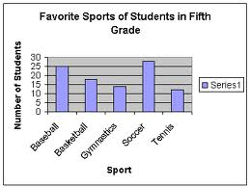
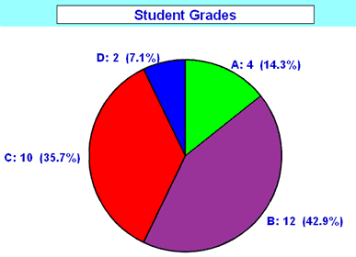
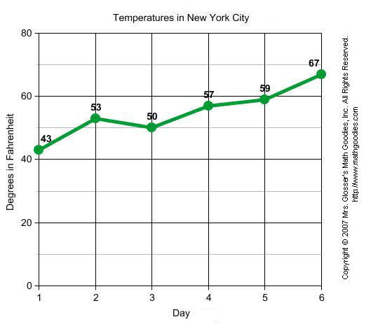
Photographs: Pictures can be used to help understand the testing process.
Making an Excel
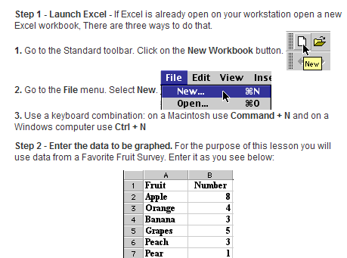
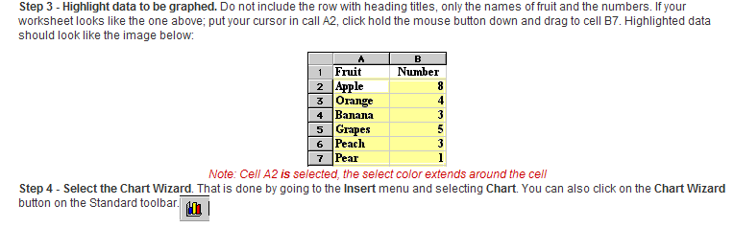
Graph:
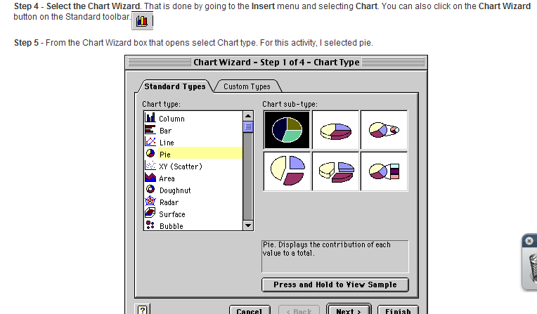

Reflection
Sentence 1: (Summarize your challenge)
_______________________________________________________________________________
_______________________________________________________________________________
_______________________________________________________________________________
Sentences 2: (explain how your research helped you in planning your design) ______________________________________________________________________________________________________________________________________________________________
_______________________________________________________________________________
Sentences 3: (What was the hardest problem to solve when building or testing your design?) ______________________________________________________________________________________________________________________________________________________________
_______________________________________________________________________________
_______________________________________________________________________________
Sentences 4-5: What were the different steps that you took to get your design to work the way you wanted it? ______________________________________________________________________
______________________________________________________________________________________________________________________________________________________________
Sentence 6-7: Give a summary of your testing data including SPECIFIC data numbers. _______________________________________________________________________________
______________________________________________________________________________________________________________________________________________________________
Sentence 8-9: What do you think was the best feature of your design and why? ________________
_____________________________________________________________________________________________________________________________________________________________________________________________________________________________________________
Sentence 10: What would you do differently if you had more time? _________________________
_____________________________________________________________________________________________________________________________________________________________________________________________________________________________________________

* Type this into a 10 or more sentence paragraph for your display board.

Display Boards:

The display board is the last step in your Einstein Jr. Project. You must use a three-section board. Your teacher will show you an example of a display board that you will need to purchase.
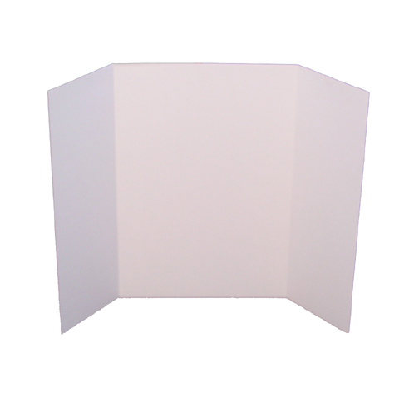

Each display board must have a title and the following headings:
Challenge: State your challenge/problem in the form of a question.
Research: Summarize (IN YOUR OWN WORDS) the background research and scientific concepts. DO NOT cut & paste! Make sure to include source citation.
Design: Make sure to include your Blueprint!
Materials: All items used for the project are listed in specific terms (quantity, brand, size, etc.)
Procedure: Clearly list steps followed in building AND testing procedures so that your project could be repeated.
Test: Data table (with titles &units) clearly shows information collected during the project.
Results: Graph(s) (bar, line, or other) labeled with titles & units to show what happened during BOTH initial design & revised design testing phases .Photos of OR actual finished products.
Reflection: Following outline provided
Name, Date, & Per. In the lower right corner of the display board

Under each heading you will type in 16 point font the appropriate information from the previous sheets of paper that were handed into your teacher.

Below is a sample way to organize your display board.

Research

Design

Title
Challenge

Materials

Procedure

Test

Results

Reflection
Name
Date
Period

# | Requirement | Possible Points | Points Earned
 | Creative title in 72 size font. | 5
 | Name, date, & period (lower, right hand corner, typed). | 5
 | Challenge | 5
 | Research | 5
 | Design/Blue Print (created in class) | 5
 | Materials | 5
 | Procedures written in sequential order. | 10
 | Test/ Data Table | 10
 | Results (2 entries): Graph(s) PLUS finished products OR photos | 10
 | Reflection answering questions on handout. | 10
 | No grammatical, spelling or punctuation errors. | 10
 | Neatness: Display board is attractive, colorful, typed, evenly spaced, heading are straight, NO tape was used, etc. | 10
 | Following directions | 10
Einstein Jr. Display Board Rubric

Total: _________
100

Letter Grade: ______
Helpful Hints!
- Mount heading on colorful paper.
- Use readable fonts
- Make sure edges of paper are straight!
- NO TAPE!
- Make sure all items are securely attached to display board.
- EVERTHING ON THE BOARD MUST BE TYPED in black ink in 16 point font (except the title)!!!

